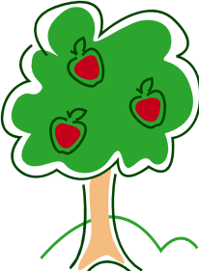

Orchard Out of School Club Club - Information for Parents
What?
Orchard Out of School Club is local service for families who need afterschool childcare and are looking for a safe, caring and happy environment for their children.
Run in partnership with Orchard Preschool, it is open term-time from 2-5.30 pm, Monday-Friday at:
14 Ballyhegan Road, Loughgall, Co. Armagh, Northern Ireland, BT61 8PX

Children will be collected at 2pm by club staff, and then walked over to club. Children finishing at 3 o’clock will walk over to the club where staff will be waiting.They will have a light snack and can join in a variety of indoor and outdoor play activities, suitable for Primary one to Primary seven.
How?
All children must be registered with Out of School Club to be able to attend sessions. Families can then choose the Sessions they wish to attend: Session 1 (2-3pm), Session 2 (3- 5.30pm) and Session 3 (2 -5.30pm).
Fees are based on an hourly rate, by the number of children in a family attending, as follows:
 | Price / Hour
1 Child | £3.50
2 Children | £6.00
3 Children | £8.50

(Fees will be charged in alignment to the full duration of sessions booked)
Families will be required to book one month in advance to allow for staffing rotas to be planned and will be billed at the start of each month. Additional sessions may be booked and will be charged on your next bill.
Payment will be by cash, cheque or childcare vouchers in advance at the beginning of the month.
For further information: to arrange a visit or to request a Registration Form:
Tel: 02838 891775 Email: orchardplaygroup@live.co.uk
Registration Forms can also be downloaded from our website: www.orchard-preschool.co.uk
Or ask our club staff at school pick-up – they will have Registration Forms with them and will be happy to answer any questions you may have.

